23.47:

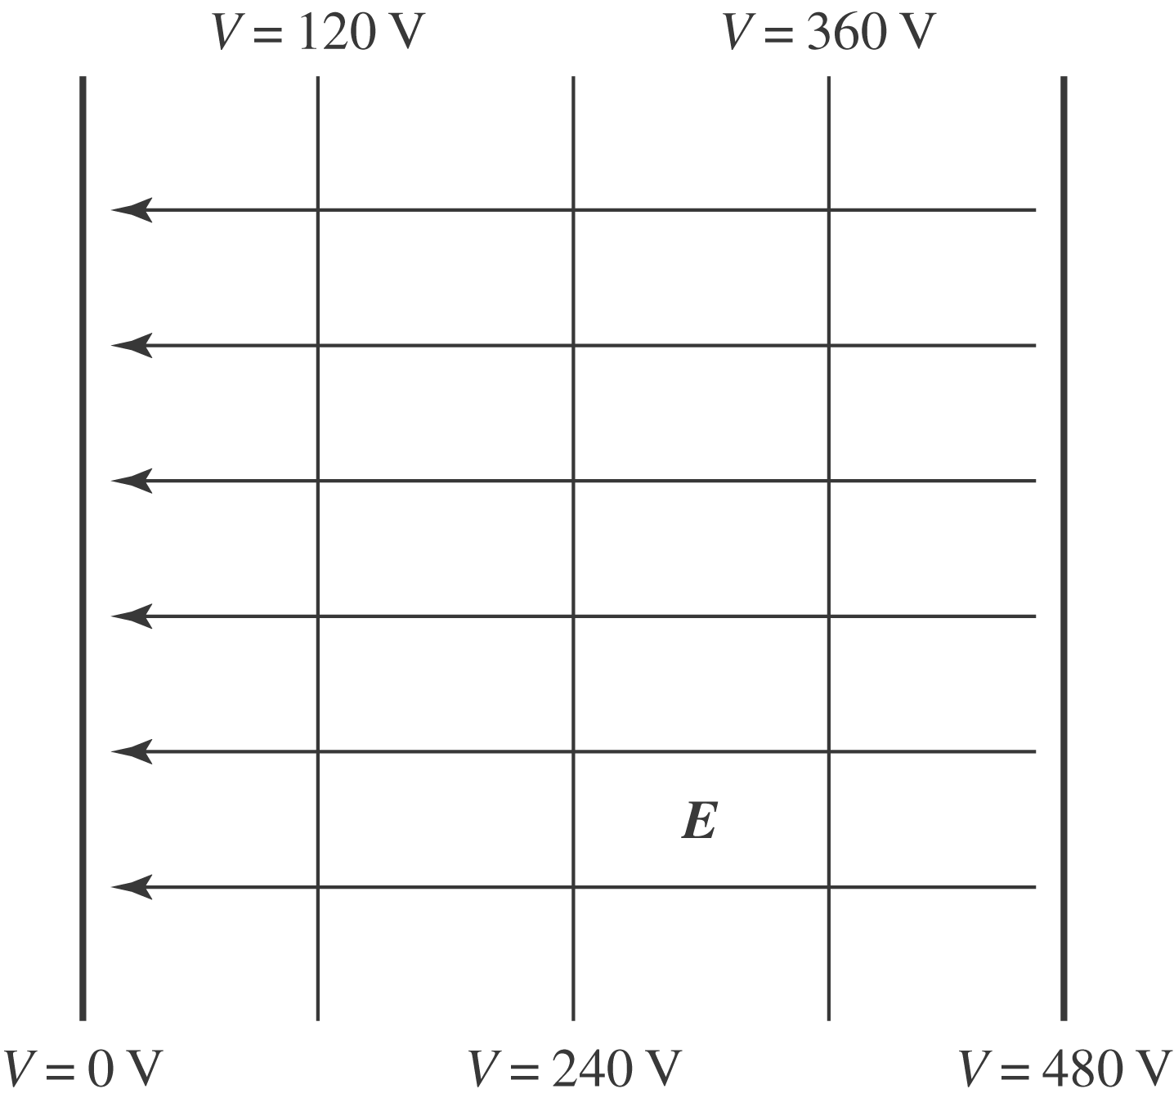
a) Equipotentials and electric field lines of two large parallel plates are shown above.
b) The electric field lines and the equipotential lines are mutually perpendicular.

